Iteration 3

Customer meeting date to demo this iteration:

We meet every Thursday morning at 11:00

User stories implemented in this iteration:

We do the “remember me ” in login and log out. Also finish the mainPage and mySubmission Page. And login, logout mainPage and mySubmission test, also the integration test.

Feature: Add a remember me function and mySubmission page

As a user

So that I can remember the username to be easier and also use mySubmission page to

chech what I have done

I want to be easier and check what I have submitted.

Heroku

<https://mighty-anchorage-26401.herokuapp.com>

Github

<https://github.com/marshalma/DiseaseDatasetCuration>

Pivottracker:

https://www.pivotaltracker.com/n/projects/1565533

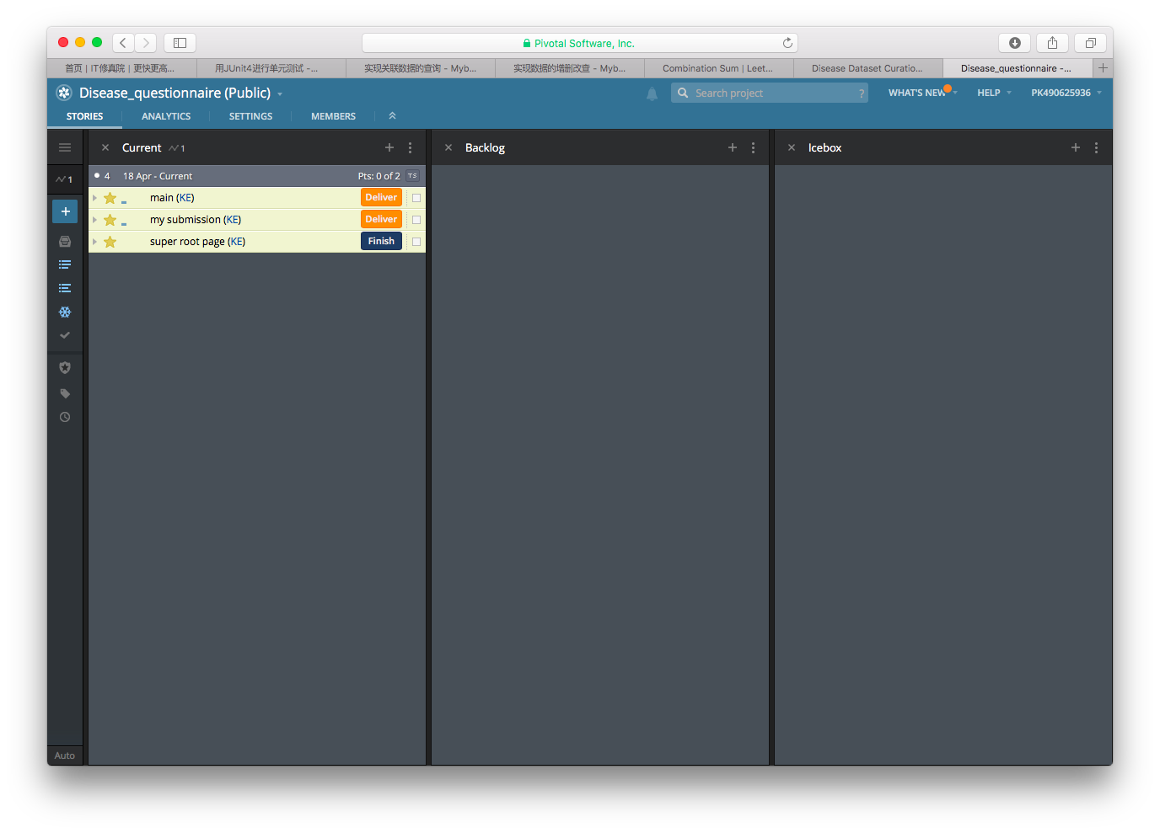

BDD

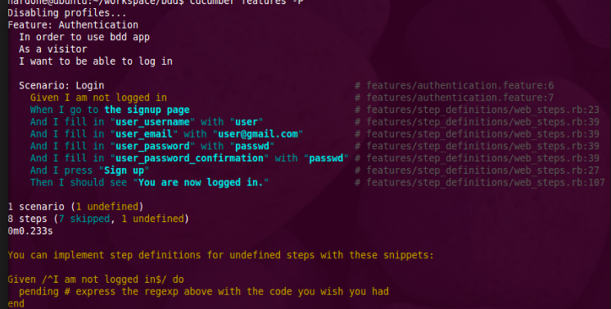

TDD

